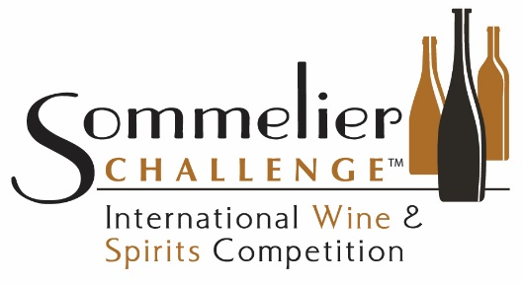

PRESS RELEASE

Sommeliers Go Rogue on Wine, Regal on Spirits
San Diego, Calif. (Oct. 10, 2022) - The 15th annual Sommelier Challenge International Wine & Spirits Competition, held Sept. 23-24, did what blind tastings often do - reveal both long-time quality producers and new quality players in the arena - and a few surprises. This year's surprise led to the creation of a new award – the Wine Region of the Year, awarded to Southern Oregon's Rogue Valley.
Most wine enthusiasts are more familiar with Oregon's Willamette Valley than this area near the border with California, but last month’s judging showed that Rogue is worthy of attention. Of the more than a dozen wines entered from this AVA by three different producers, 93% received medals, and 86% of those medals were Gold or Platinum. Competition judging was conducted by panels of certified Sommeliers in a blind-tasting format. In addition to winning top awards, four of the wines from Rogue Valley took Best of Class honors: Belle Fiore’s 2019 Souspire (Best Red Blend), Coventina Vineyards’ 2016 Tempranillo (Best Tempranillo), StoneRiver Winery’s 2019 Mouvedre (Best Mourvedre), and StoneRiver Winery’s 2018 Petite Sirah (Best Petite Sirah) in a three-way tie with J. Lohr of Paso Robles and Mia Bea Wines in Mendocino.
Of course, the usual suspects made themselves known as well. Tom Eddy Winery of Napa took the domestic Wine of the Year and Winery of the Year crowns thanks to some outstanding Cabernet Sauvignon entries, including its 2016 Stagecoach Vineyard Cabernet Sauvignon that was awarded Best of Show Red Wine. Australia's Wakefield (Taylors in Australia) took yet another Import Winery of the Year award with their usual high quality showing. Canapino's Vino Nobile di Montepulciano took the Imported Wine of the Year award with a truly noble Sangiovese priced for the people.
On the Spirits front, the top awards went to a company headed by music royalty Earl Stevens (better known to fans as "E-40") with his Tycoon Cognac VSOP wowing the judges and taking the Spirit of the Year trophy. "The Earl" also scored with the E. Cuarenta Reposado, which took Best Tequila props. Continuing in the regal vein, Highclere Castle took Best Gin accolades with a classic expression of London Dry Gin.
For details on all 2022 Sommelier Challenge award winners in both wine and spirits categories, go to Sommelier Challenge Competition Results.
Sommelier Challenge International Wine & Spirits Challenge was founded in 2008. Each year the competition brings together brilliant teams of Sommeliers, assembled by Chief Judge Jesse Rodriguez, to serve on judging panels. Silver, Gold and Platinum medals are awarded, as well as “Best of” categories. The competition is one of the Challenge Series of international wine and spirits competitions founded by noted wine critic and wine-and-spirits writer Robert Whitley that includes Critics Challenge, Winemaker Challenge, and the San Diego International Wine & Spirits Challenge.
###
Media Contact: Diane Salisbury, President, Wine Cellar Productions
619-807-8560
diane@winecellarproductions.com

