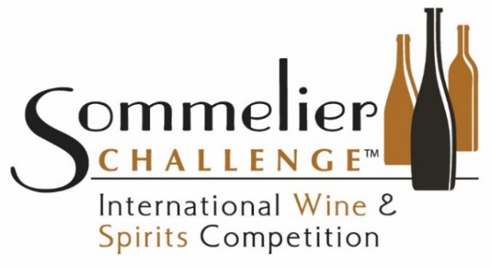
September 20 & 21, 2025
Spirits Entry Form
(For wine entries see separate
entry form on competition website)

Company or Brand: .  Mailing address: .  (address to which any award notification or correspondence will be sent)  .  City, State, Zip: .  Country of Origin, and the state if US: . | Contact Person: .  Phone: . Ext or Dept: .  Email: _____ .  Parent Company/ Importer/ Marketer submitting this entry if other than producer.  .  Website: .  Twitter: ___________________________________________ | Number of Spirits entered:  .  X $275 if paid by August 8  $300 after August 8  $ Total Entry fee  Make check payable to  Wine Cellar Productions  or provide credit card info.
\

For competition staff use only Entry: _________________

Payment $: _____________ Input date:______________

Payment date: ___________ Received: ______________

Check/Charge:___________ Cellared: _______________

TO CHARGE ENTRY FEE: Visa, MasterCard, American Express only. Note: Charge will appear as “Wine Cellar Productions”.

Credit Card # : . Expiration: . Security Code: .
Name on card: .
Credit card billing address: .
For your security, delete credit card information on shipping copy of entry form.

For instructions, rules and codes or to enter online, go to www.SommelierChallenge.com. If you enter online you do not need to complete this form. Fees are due at time of entry. Name of Spirit, Designations and Origin will appear on Award Certificate so must be as it appears on the label. Include copy of entry form with shipment. Send two 750ml bottles or three 500ml bottles of each spirit (or equivalent) to: (NEW ADDRESS) Sommelier Challenge, Attn: Rich Cook, 1121 Britem Court, Vista, California 92083. Product deadline is September 12, but you are encouraged to ship at your earliest opportunity.

Category  Code | Product Name including Brand if different than above  Designations if any that appear on label | Age | Region or Type | Region or  Country of Origin | Alcohol  Percentage % | Bottle Size  (ML) | Retail  Price  USD $

Additional space and important entry information on Page 2 or reverse. Note: This form is for entering spirits. Enter wines on the Wine entry form on website, SommelierChallenge.com.

2025 Sommelier Challenge
Spirits Entry Form
Page __ of __

Name: . Parent Co if any: . Number of Spirits Entered: .

Go to www.SommelierChallenge.com to enter online. If you enter online you do not need to complete this form.
NOTE: Use this page (and additional copies of it as needed) only after completing page one of the entry form so that we have your contact information.

Category  Code | Product Name including Brand if different than above  Designations if any that appear on label | Age | Region or Type | Region or  Country of Origin | Alcohol  Percentage % | Bottle Size (ML) | Retail  Price  USD $

SEND THIS ENTRY FORM AND FEES TO:

Sommelier Challenge
Attn: Rich Cook
1121 Britem Court
Vista, California 92083

Or Email to Sommelier_Challenge@yahoo.com

PRODUCT SHIPPING: Send two (2) 750ml or three (3) 500ml bottles, or equivalent, of each spirit to be received no later than September 12. SHIP TO:

Sommelier Challenge
Attn: Rich Cook
1121 Britem Court
Vista, California 92083

CONTACT:

Competition Director Rich Cook, 760-522-3167
WineWiseGuy@me.com

SommelierChallenge@yahoo.com

NOTE: The best way to enter is online. See competition website for online entry and rules, entry codes and other information. If you enter online you do not need to complete this form. Type or PRINT CLEARLY. Use of your own form is acceptable (Excel or Word) if ALL information is given. Keep a copy of completed form and enclose a copy with shipment. Incomplete or inaccurate information may result in product not being judged under the best circumstances. Competition is not responsible for entry or shipping errors. For Name, include Brand Name if different than Company. Give size and type of container if other than standard 750ml glass bottle. Mark each box “Sommelier Challenge” and indicate total shipped (example: “Box 1 of 3”). All entries become the property of the competition and cannot be returned. All shipping, customs and other such charges are the responsibility of the sender. If changes must be made after entry, send an entry form marked “REVISED” to SommelierChallenge@yahoo.com. If you need to cancel after submitting entries, whether by form or online, please notify us as soon as possible. Important: If you are shipping from outside USA see instructions on website regarding labeling requirements and Customs assistance if needed, and ship asap to allow time for shipping and Customs clearance.
Thank you for entering Sommelier Challenge International Wine & Spirits Competition.
Rev 11-14-2024

